|  |  |  |  |
| --- | --- | --- | --- |
| **F:\Learning bugs\Foundation Subjects\Dolly the Fly - Science.jpgLyng Primary School Knowledge Organiser** | | | |
| **Topic:** | **Science**  **Animals Including Humans – Circulation & Health** | Year 6 | Summer 1 |



**Notable scientists**

William Harvey  
(1578-1657)

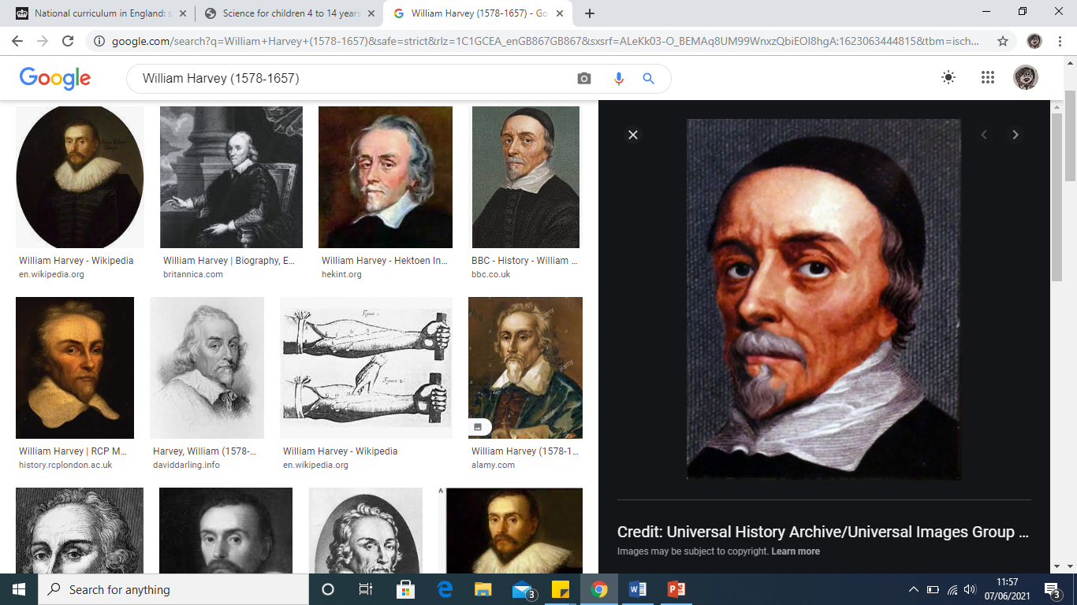

**What should I already know?**Children will build on their learning from Years 3 and 4 about the main body parts and internal organs (skeletal, muscular and digestive system) and will start to explore and answer questions that help them to understand how the circulatory system enables the body to function.

|  |  |
| --- | --- |
| **What Step On and Goldilocks words will I use?** | |
| **Spelling** | **Definition** |
| Alcohol | A drug produced from grains, fruits or vegetables when they are put through a process called fermentation. |
| Balanced diet | A diet that includes all seven nutrients in the right amounts. |
| Blood | The red liquid pumped around the body in blood vessels to transport substances. |
| Bloodstream | The flow of blood around the body. |
| Blood vessels | The tubes that blood flows in around the body. |
| Carbon Dioxide | A waste gas produced by the body. |
| Circulatory System | The group of organs responsible for transporting blood around the body. |
| Diet | The kinds of food a living thing eats. |
| Drug | A substance that changes the way the body and brain works. |
| Exercise | Physical activity that moves your body. |
| Heart | A muscular pump that pushes blood around the circulatory system. |
| Lifestyle | The way a person lives. |
| Nutrients | Substances that animals need to stay alive and healthy. |
| Oxygen | A gas used by the body that is essential for life. |
| Oxygenated blood | Oxygenated blood has more oxygen. It is pumped from the heart to the rest of the body. |
| Pulse | The regular beating of the heart, felt as the movement of blood through specific points of the body. |
| Pump | To force gases or liquids to move |
| Transport | To move something around from one place to another. |

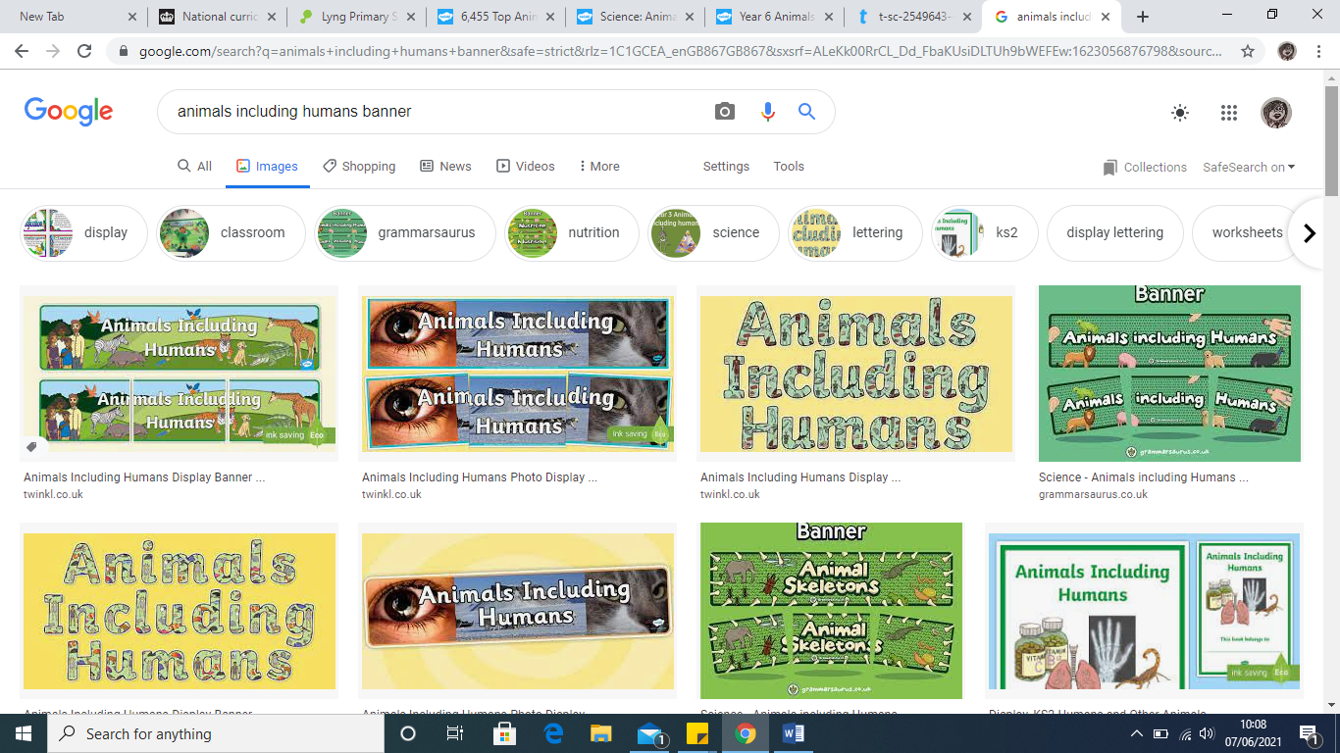

|  |
| --- |
| **Enquiry Questions** |
| * What factors affect our health? * What are the key structures and purpose of the circulatory system? * What are the key roles of blood? * What is the relationship between animal size and hearth rate? * How can we investigate the relationship between exercise and heart rate? * What is the relationship between heart rate and fitness? |

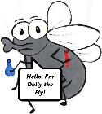

**What will I know by the end of the unit?**

|  |
| --- |
| Children will… |
| …identify and name the main parts of the human circulatory system, and describe the functions of the heart, blood vessels and blood. Children will Work  Scientifically by researching all of the parts of the human circulatory system  and then piece together each part correctly (LOTC opportunities) |
| …recognise the impact of diet, exercise, drugs and lifestyle on the way their bodies function. Children will link unit with PE to explore the positive impact a healthy diet and regular exercise has on our bodies. This will also link with the work previously completed in PSHE (Healthy Me) which we completed in Spring Term. |
| …describe the ways in which nutrients and water are transported within animals, including humans. Children will learn more about the digestive system and the different nutrients found in different diets and focus on the six major nutrients: Carbohydrates (CHO), Lipids (fats), Proteins, Vitamins, Minerals and Water. Children will also gain a deeper understanding of how to build a ‘healthy plate’ focusing on the appropriate percentages of nutrients. |

|  |  |  |  |
| --- | --- | --- | --- |
| **F:\Learning bugs\Foundation Subjects\Dolly the Fly - Science.jpgLyng Primary School Knowledge Organiser** | | | |
| **Topic:** | **Science**  **Animals Including Humans – Circulation & Health** | Year 6 | Summer 2 |

|  |  |  |
| --- | --- | --- |
| 1. Which of these has a positive effect on health? | **S** | **E** |
| 1. Sitting for long periods of time. |  |  |
| 1. Drinking water regularly. |  |  |
| 1. Staying away from people. |  |  |
| 1. Drinking alcohol |  |  |

|  |  |  |
| --- | --- | --- |
| 1. What is the main function (job) of the circulatory system? | **S** | **E** |
| 1. To produce oxygen. |  |  |
| 1. To digest food. |  |  |
| 1. To transport substances. |  |  |
| 1. To make new blood. |  |  |

|  |  |
| --- | --- |
| 1. What is the function (job) of the heart? | |
| **S** |  |
| **E** |  |

|  |  |  |
| --- | --- | --- |
| 2. Which of the following is NOT found in blood? | **S** | **E** |
| 1. Undigested food. |  |  |
| 1. Water. |  |  |
| 1. Sugar. |  |  |
| 1. Oxygen. |  |  |

|  |  |  |
| --- | --- | --- |
| 1. What effect do drugs have on the circulatory system? | **S** | **E** |
| 1. No effect. |  |  |
| 1. Always a bad effect. |  |  |
| 1. Make the heart smaller. |  |  |
| 1. Can change how it works, which can cause damage. |  |  |

|  |  |
| --- | --- |
| 1. What is the function (job) of the heart? | |
| **S** |  |
| **E** |  |

|  |  |
| --- | --- |
| 1. What happens to the circulatory system during exercise? | |
| **S** |  |
| **E** |  |

|  |  |  |
| --- | --- | --- |
| 1. Where in the body is oxygen picked up by the bloody and carbon dioxide dropped off? | **S** | **E** |
| 1. The lungs. |  |  |
| 1. The heart. |  |  |
| 1. The blood vessels. |  |  |
| 1. The body. |  |  |

|  |  |  |
| --- | --- | --- |
| 1. Which of these is a lifestyle choice that can negatively affect the health? | **S** | **E** |
| 1. Regular exercise. |  |  |
| 1. Eating lots of vegetables. |  |  |
| 1. Eating lots of high-fat foods. |  |  |
| 1. Drinking water. |  |  |